Department of Computer Science and Engineering
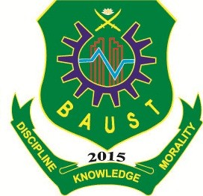
Bangladesh Army University of Science and Technology (BAUST)
Individual Class Routine & Course Load for Spring 2018
Teacher Name: Abu Saleh Musa (MSB)
Designation: Lecturer, CSE
Contact Hour: 18 hours

Day | 08.00-08.50 |  | 09.00-09.50 | 10.00-10.50 |  | 11.30-12.20 |  | 12.30-01.20 |  | 01.30-02.20 |  | 02.30-03.20 | 03.30-04.20
SUN | CSE-4101 ASM  4-1(B) 4002 |  |  | CSE-3205 ASM  3-2(A) 5002 | B  R  E  A  K | CSE-3206 ASM  3-2(A) 4008 |  |  |  |  | B  R  E  A  K
MON | CSE-3206 ASM  3-2(B) 4008 |  |  |  | B  R  E  A  K |  | CSE-4101 ASM  4-1(A) 4002 |  | CSE-3205 ASM  3-2(B) 5002 |  | B  R  E  A  K
TUE |  |  |  | CSE-3205 ASM  3-2(A) 5002 | B  R  E  A  K | CSE-3205 ASM  3-2(B) 5002 |  |  |  |  | B  R  E  A  K
WED |  | CSE-4101 ASM  4-1(A) 4002 |  | CSE-3205 ASM  3-2(A) 5002 | B  R  E  A  K |  | CSE-4101 ASM  4-1(B) 4002 |  |  |  | B  R  E  A  K
THU |  |  |  | CSE-4101 ASM  4-1(B) 4002 | B  R  E  A  K | CSE-3205 ASM  3-2(B) 5002 | CSE-4101 ASM  4-1(A) 4002 |  |  |  | B  R  E  A  K

  COURSES
  Course No. | Course Title | Hours/Week |  | Credit  Hours
  Course No. | Course Title | Theory | Sessional | Credit  Hours
  CSE-4101 | Artificial Intelligence | 3.00 |  | 6.00
  CSE-3205 | Computer Network | 3.00 |  | 6.00
  CSE-3206 | Computer Network Sessional |  | 1.50 | 6.00
   | Total |  |  | 18.00
  Signature of the Teacher

